**DAILY REPORT**

**Student Name :SINDHU.N**

**Class and Sec : VI B**

**USN :4AL17CS094**

**DATE:19-07-2020**

|  |  |  |  |  |
| --- | --- | --- | --- | --- |
| **Online Test Details** | | | | |
| **Subject** | **----** | | | |
| **Semester** | **VI -B** | | **Duration** | **------** |
| **% of marks** | | **----** | | |

|  |  |  |  |
| --- | --- | --- | --- |
| **Certification Course Details** | | | |
| **Course** | Python for Everybody | | |
| **Certificate Provider** | coursera | **Duration** | 19hours |

**Snapshots of the daily class acitivities .**

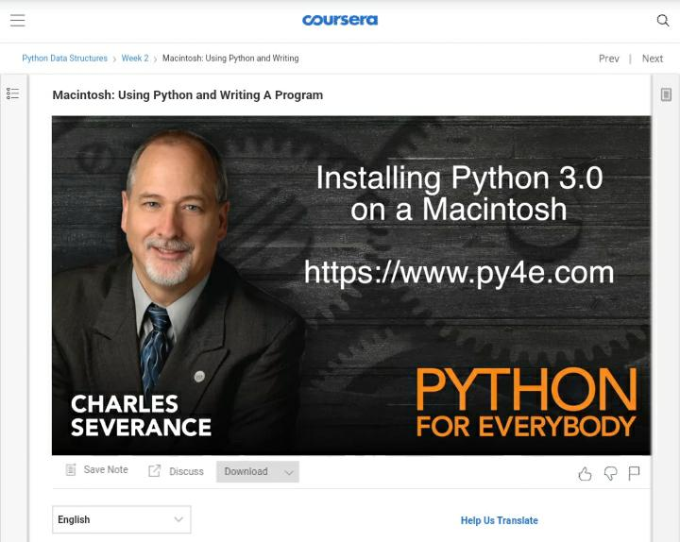

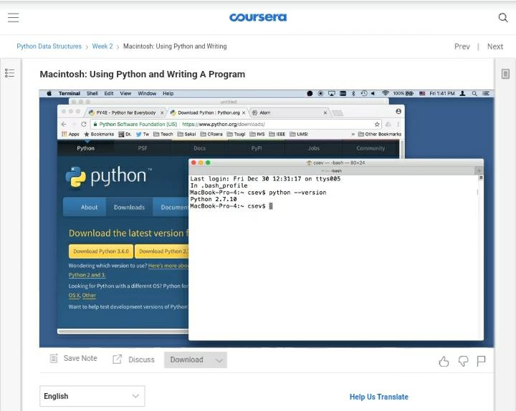

|  |  |
| --- | --- |
| **Coding Challenges** | |
| **Problem Statement: 1**.**Python Program for Number of elements with odd factors in given range.**  **2.Python Program for Common Divisors of Two Numbers.** | |
| **Status:** Executed | |
| **Uploaded the report both in Github & Slack** | Yes |

**Snapshots of your response to challenge.**

**1.**Python Program for Number of elements with odd factors in given range.****

def countOddSquares(n, m):

return int(m**0.5) - int((n-1)**0.5)

m = 100

print("Count is", countOddSquares(n, m))

**OUTPUT**

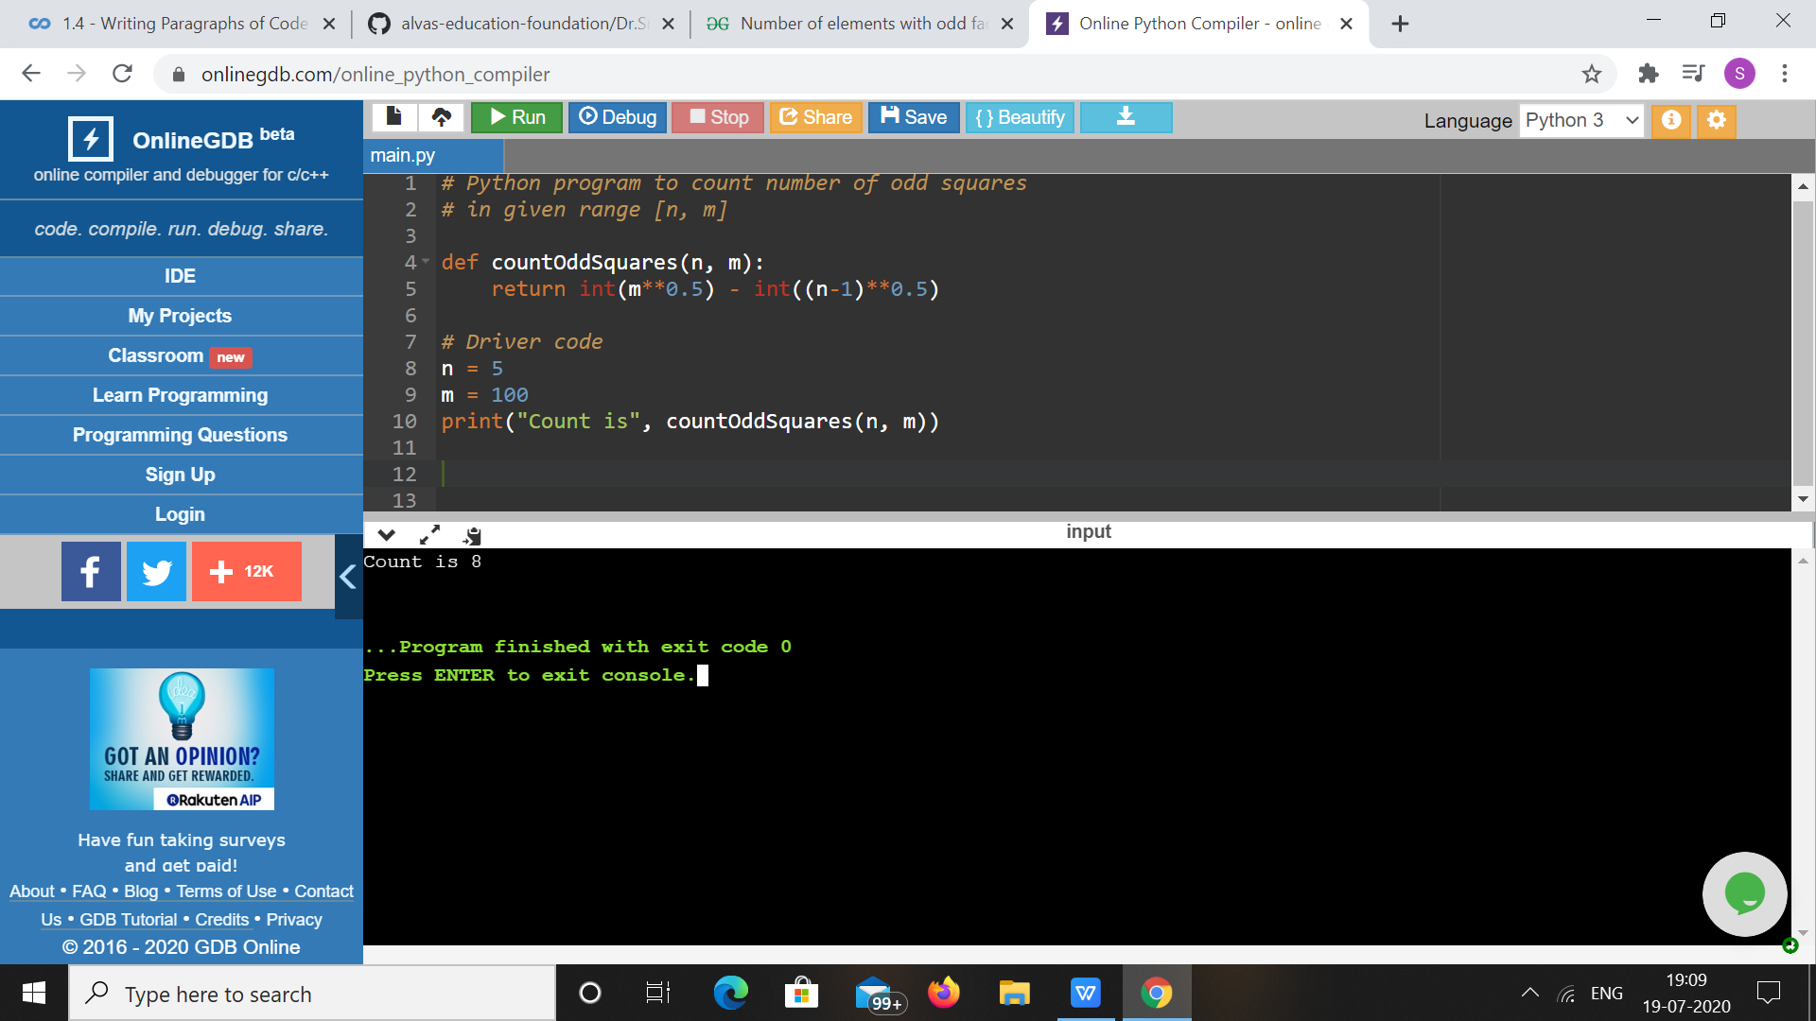

1. ****Python Program for Common Divisors of Two Numbers.****

**a = 12**

**b = 24**

**n = 0**

**for i in range(1, min(a, b)+1):**

**if a%i==b%i==0:**

**n+=1**

**print(n)**

**OUTPUT**

